

end user document

ITC511



GROUP PROJECT

PRAKASH TAMANG AND KABIN TAMANG

TUTOR; JOSH

Contents

Login 2

Select Calendar Page 3

Display Calendar can be changed 3

Add Appointment 4

Fill up the form 4

Or Choose the existing appointment 5

Check Routine 6

Edit Customer details 7

Change or fix the error 7

Deleting appointments 8

Confirm delete 8

Select Customer Page 9

Click any customer to check details 9

Result after selecting customer 10

You can edit details of customer 10

You can also delete any customer 11

Select service page 12

Click on add to add service as shown in diagram 12

Click on test service to check details 13

Click on delete to delete test service 13

Select categories 14

Select users page 15

Setting page 15

Select General 16

Select business logic 17

Select Legal contents 17

Select current user 18

About easy Appointments 18

Log out 18

# Login

Type <http://54.221.148.171/S4AppointmentsPT2/> to get to the home page of frontend section and click on login to get to backend section which will show like the below screenshot.

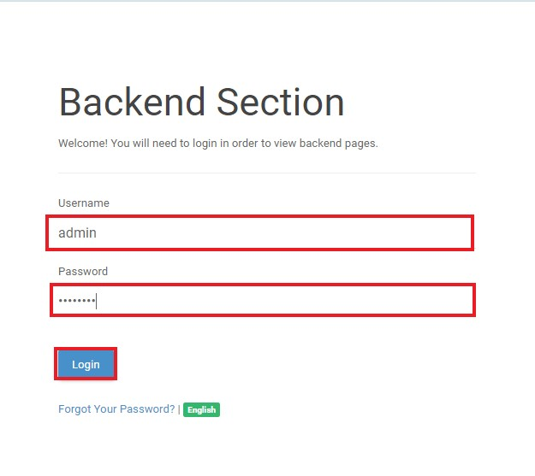

# Select Calendar Page

After you login , select calendar.

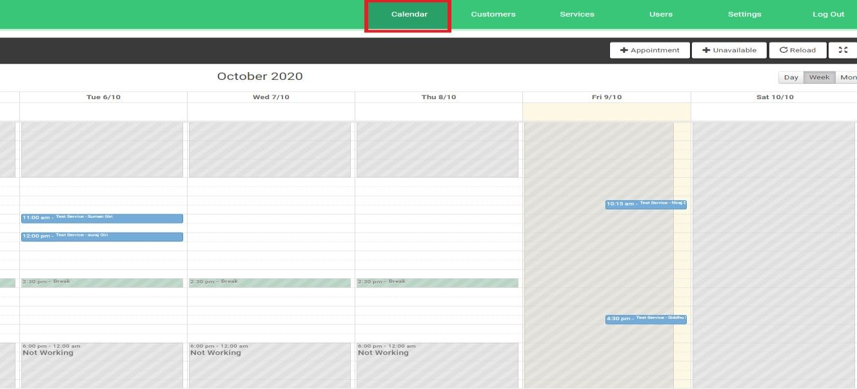

## Display Calendar can be changed

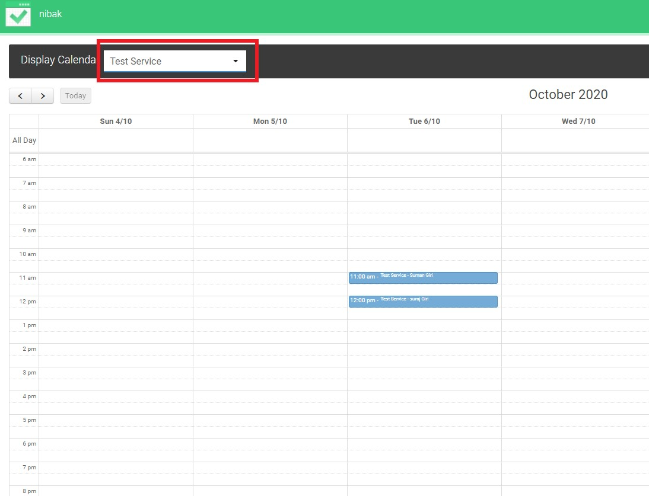

## Add Appointment

Its easy to add appointment in backend section. Just click on +appointment button to add new appointment

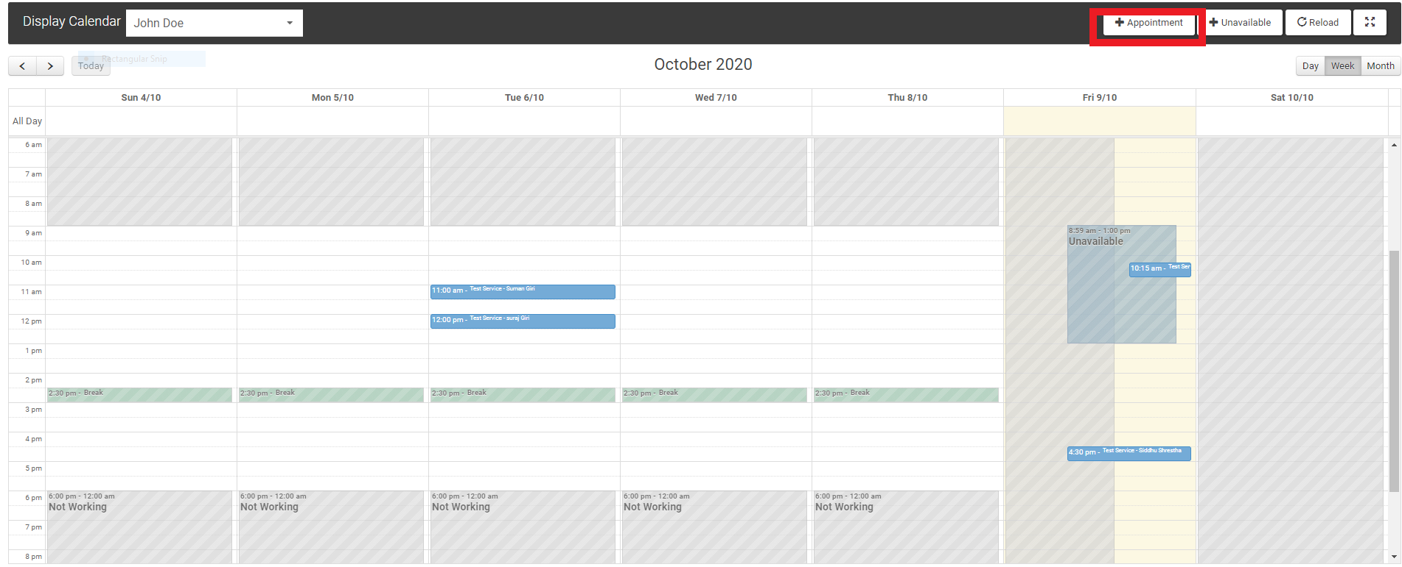

## Fill up the form

Add appointment details as given below.

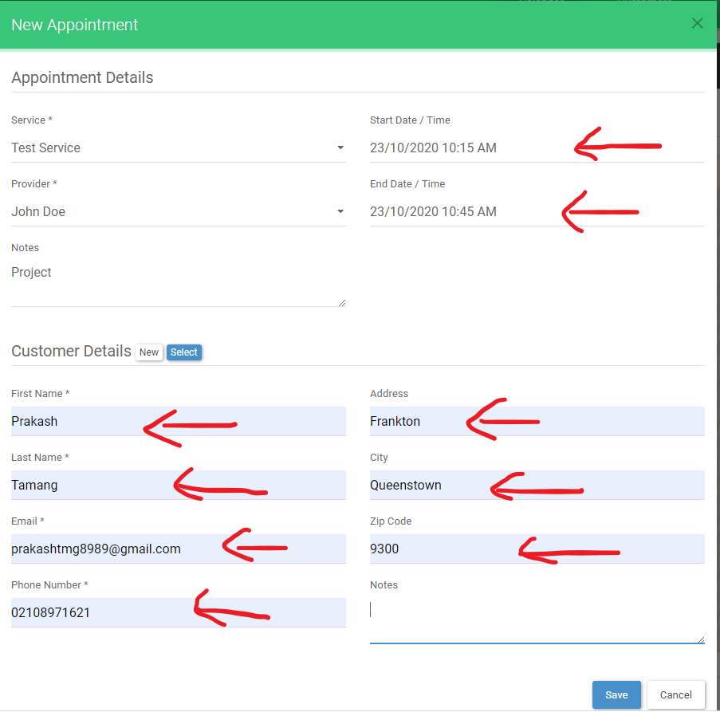

## Or Choose the existing appointment

If you have already appointment then you can select your existing appointment.

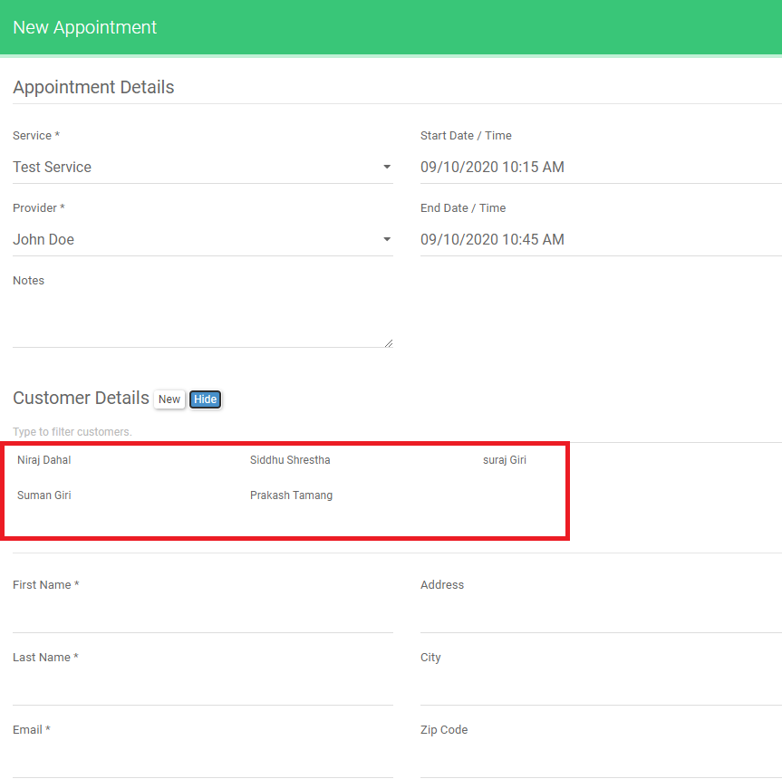

## Check Routine

Day

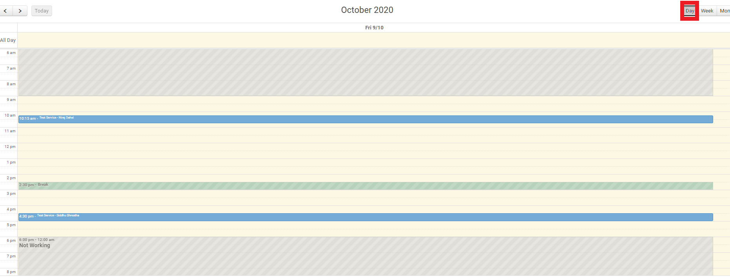

Weekly

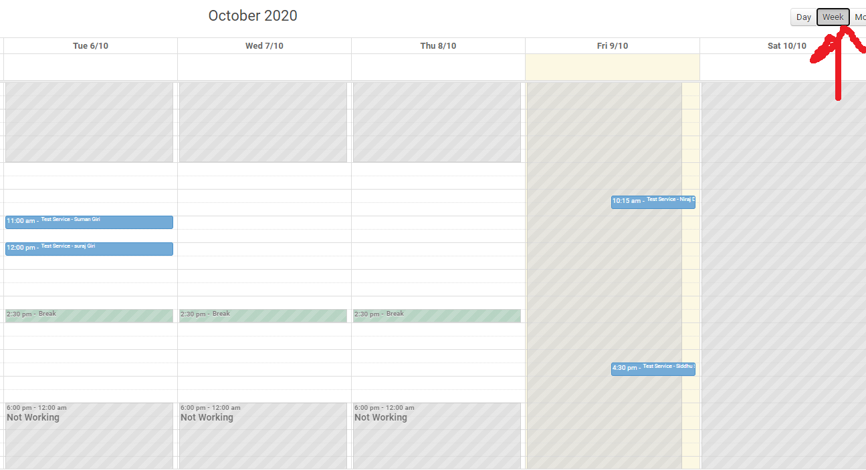

Monthly

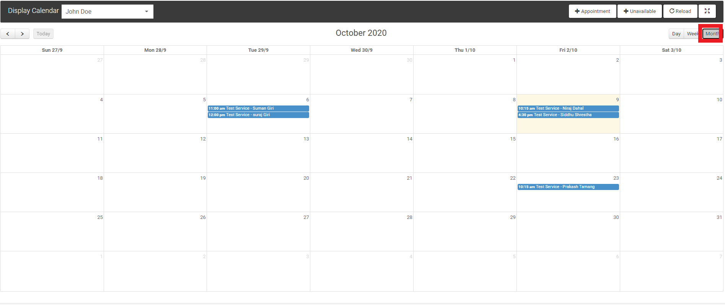

## Edit Customer details

You can also edit customer details by clicking on edit and fill the details with correct information about you or any customer.

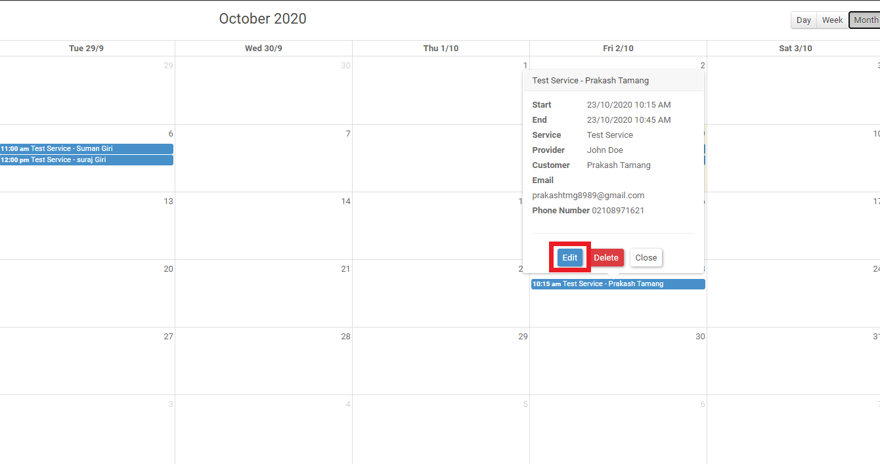

## Change or fix the error

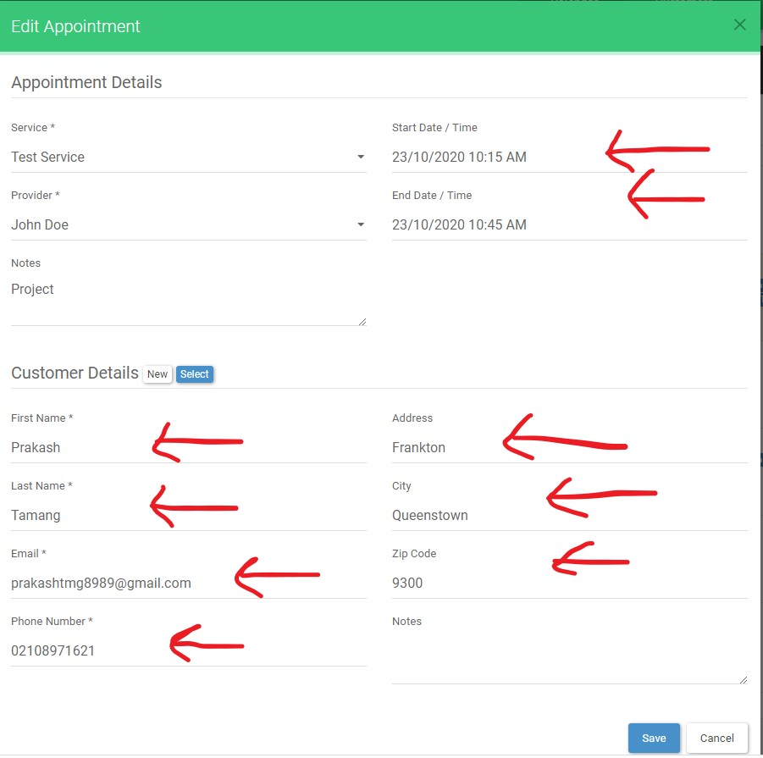

## Deleting appointments

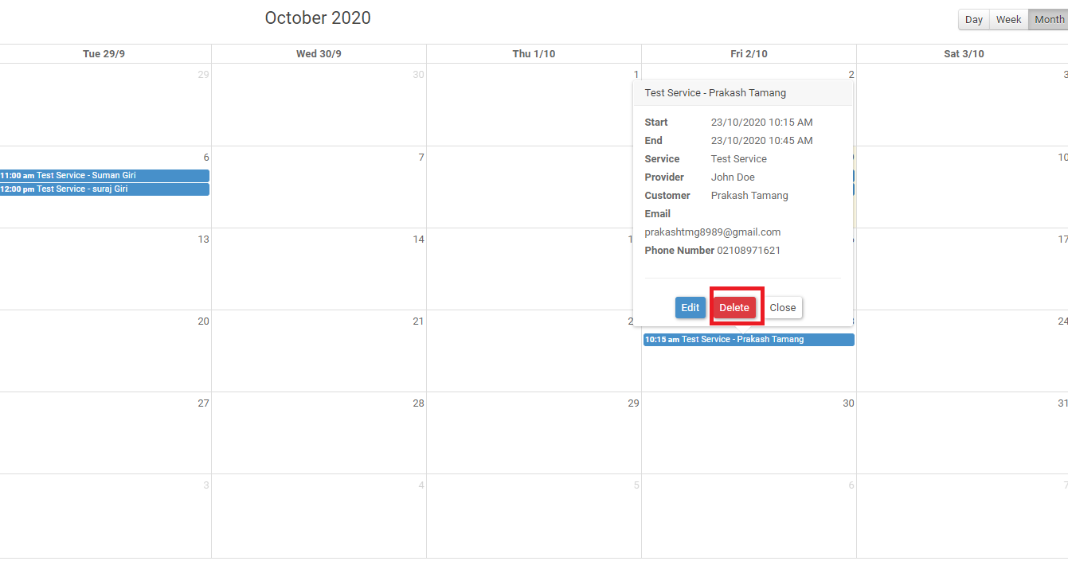

## Confirm delete

Click on ok button to confirm delete.

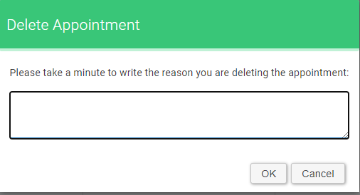

# Select Customer Page

Here you can see the details of each customer.

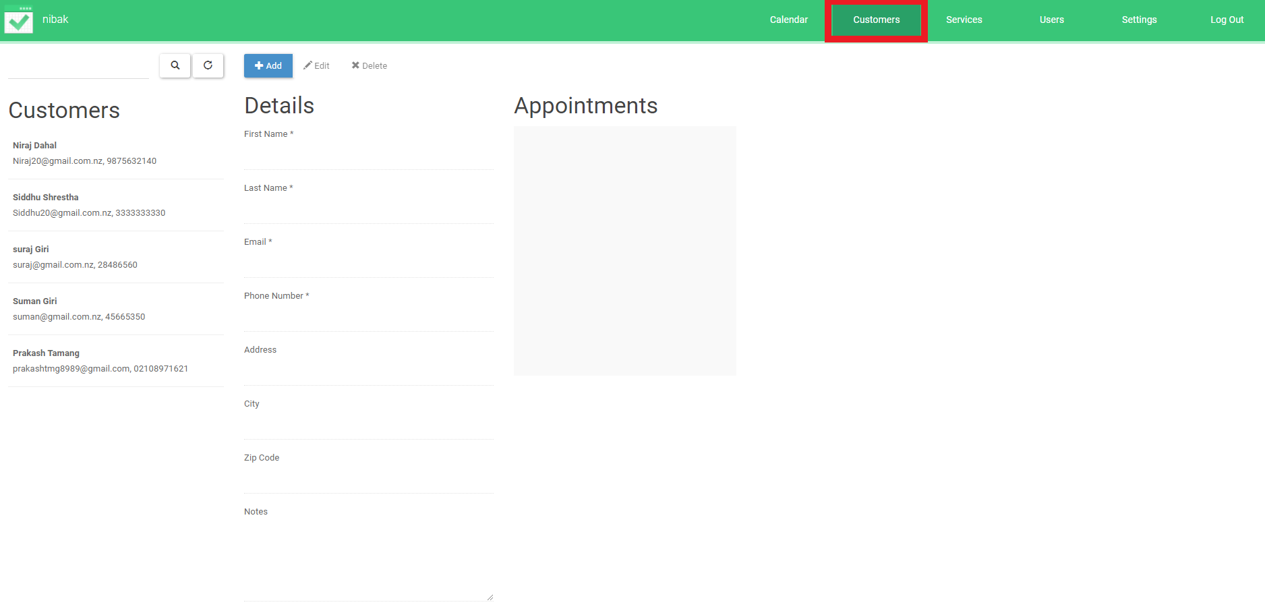

## Click any customer to check details

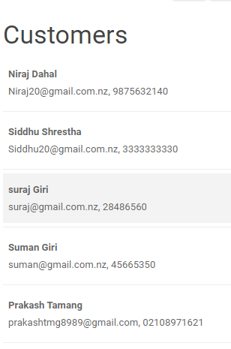

## Result after selecting customer

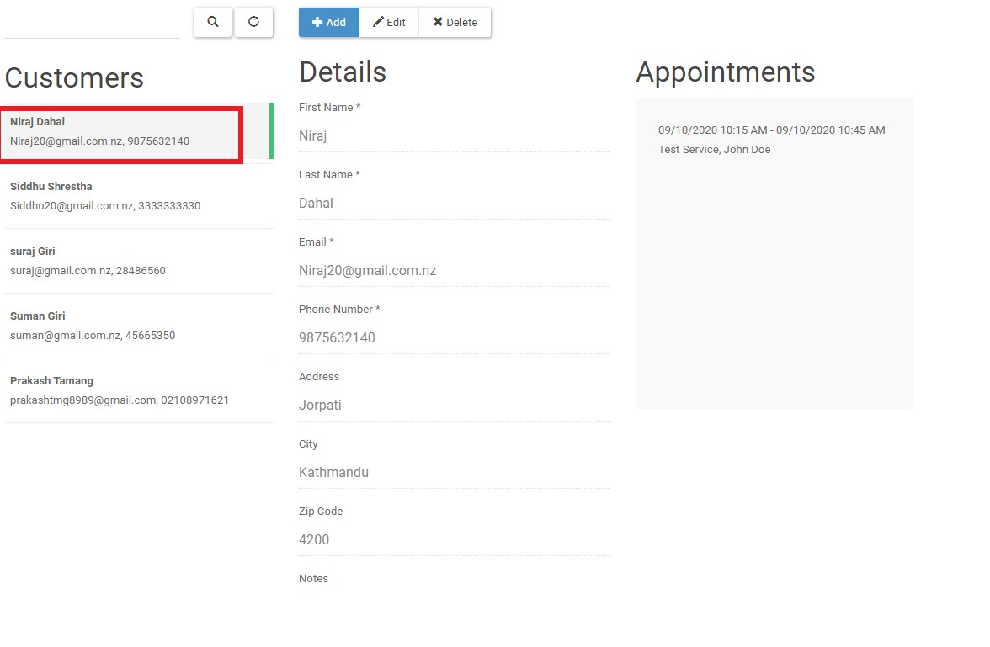

## You can edit details of customer

You can fix the bug or error and fill the valid information.

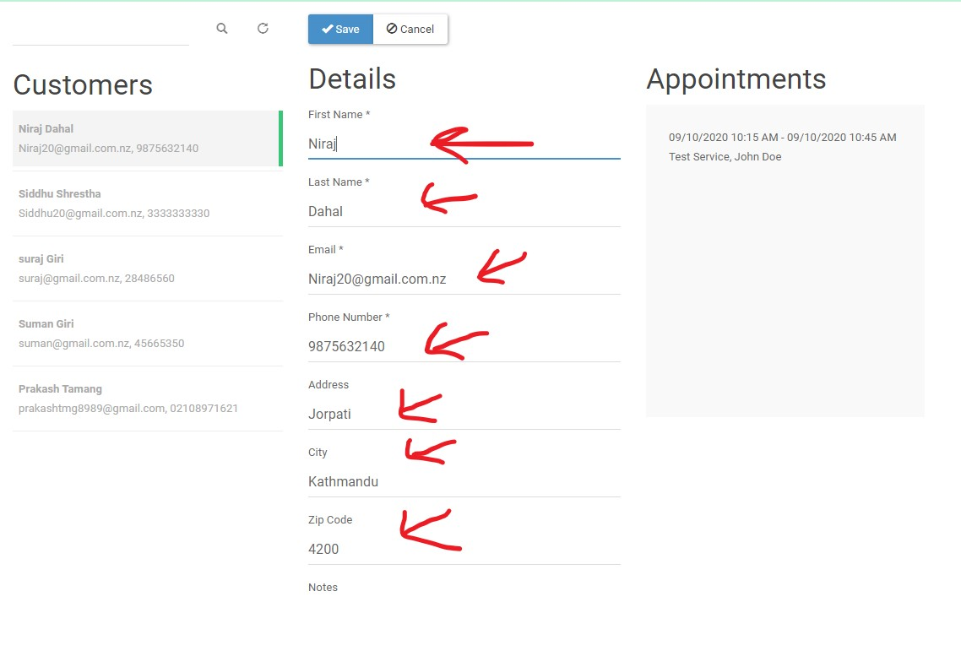

## You can also delete any customer

To delete customer, click on delete option and confirm delete.

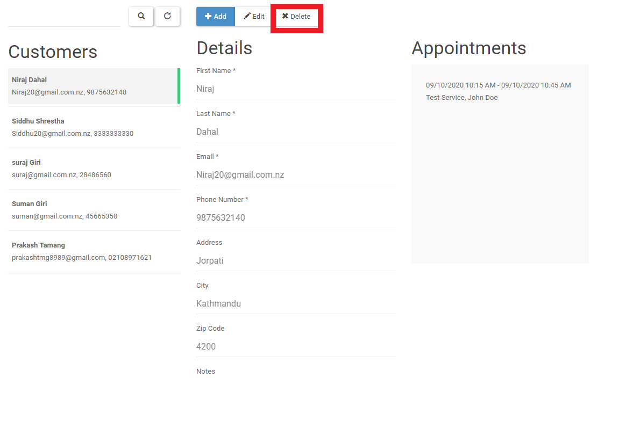

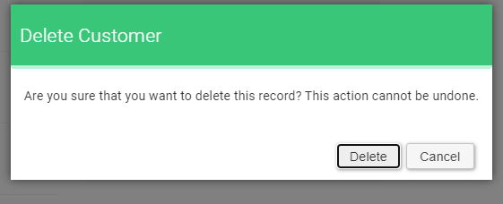

# Select service page

Go to the service page by clicking service button which is between customer and Users button.

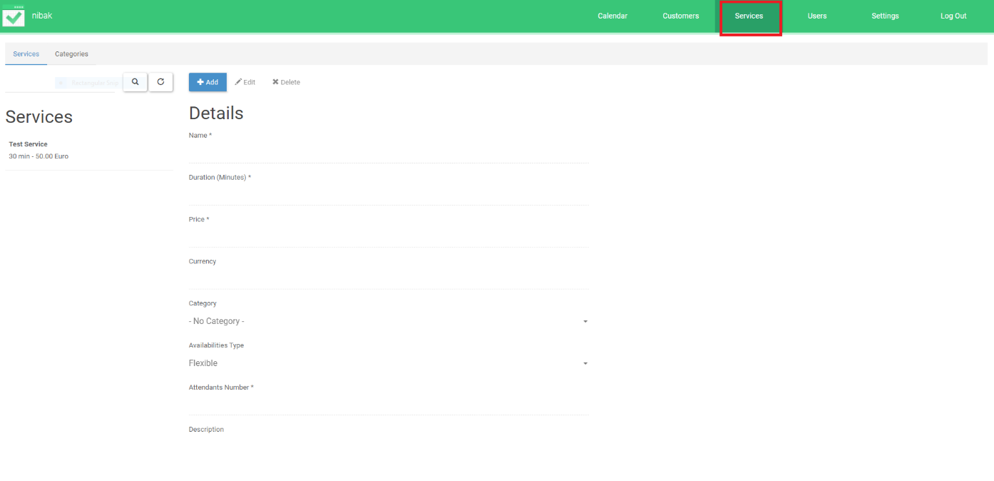

## Click on add to add service as shown in diagram

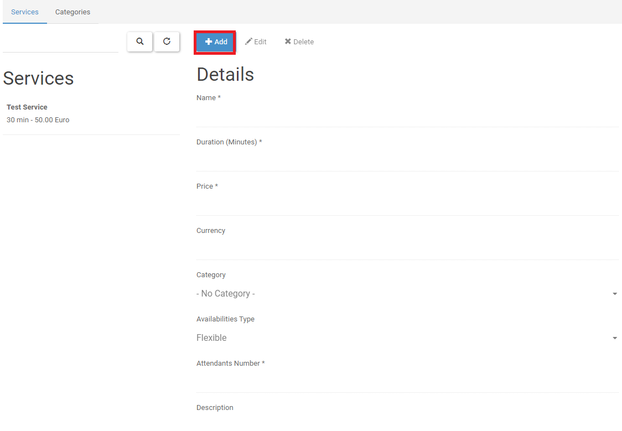

## Click on test service to check details

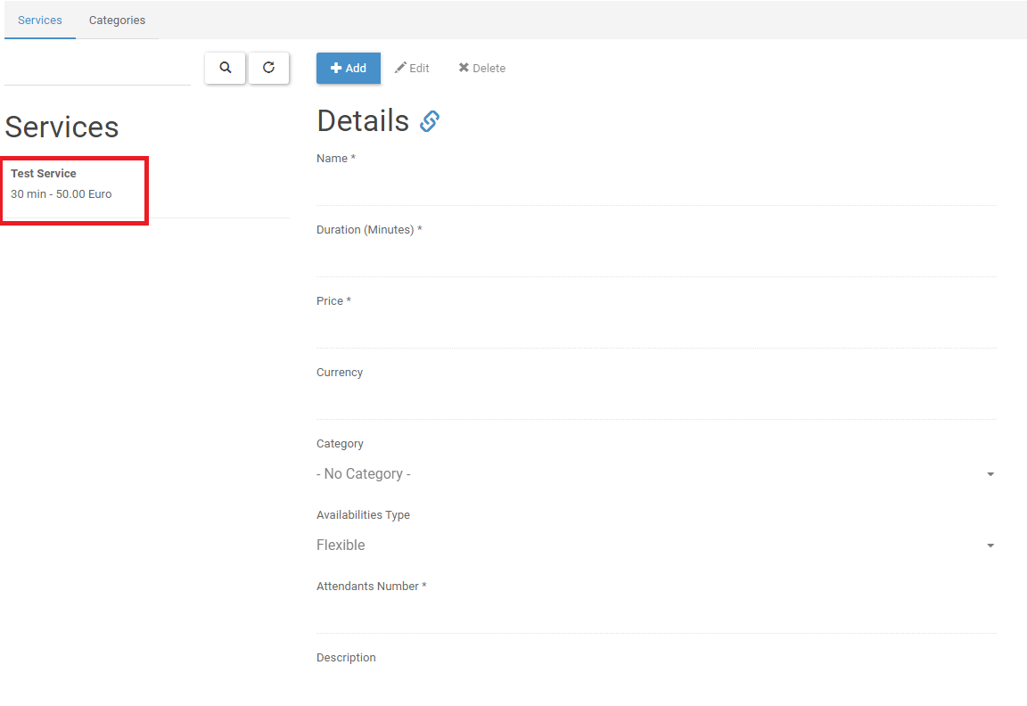

## Click on delete to delete test service

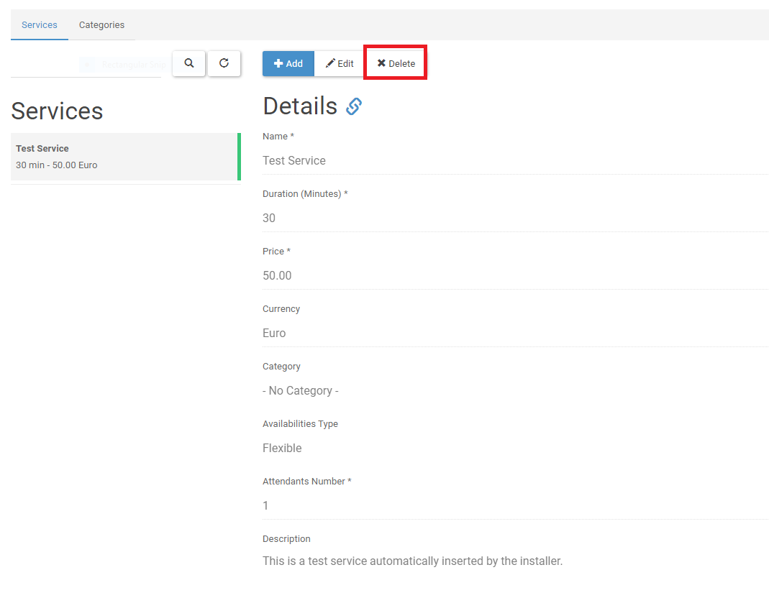

## Select categories

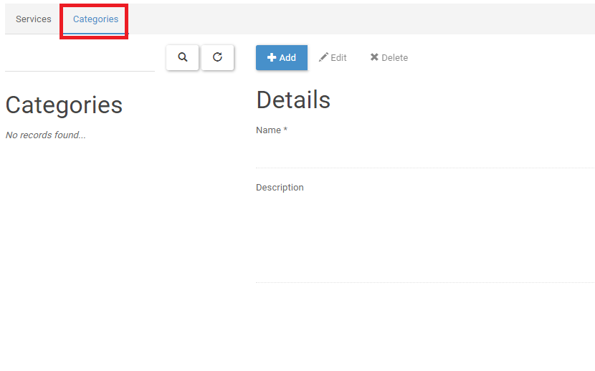

Add/edit/delete categories

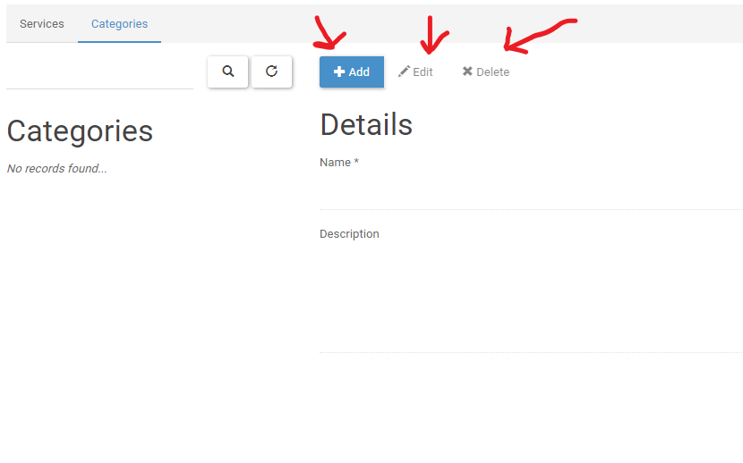

# Select users page

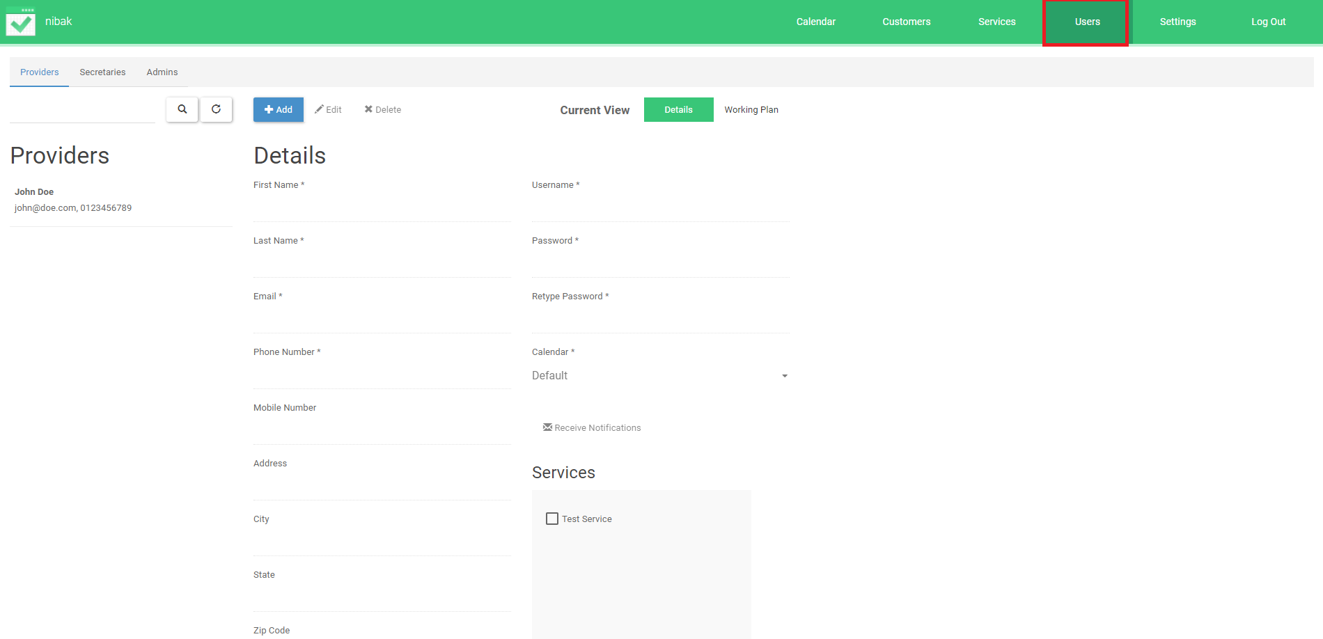

# Setting page

Here , you can change the setting of backend section and keep the suitable setting for backend section.

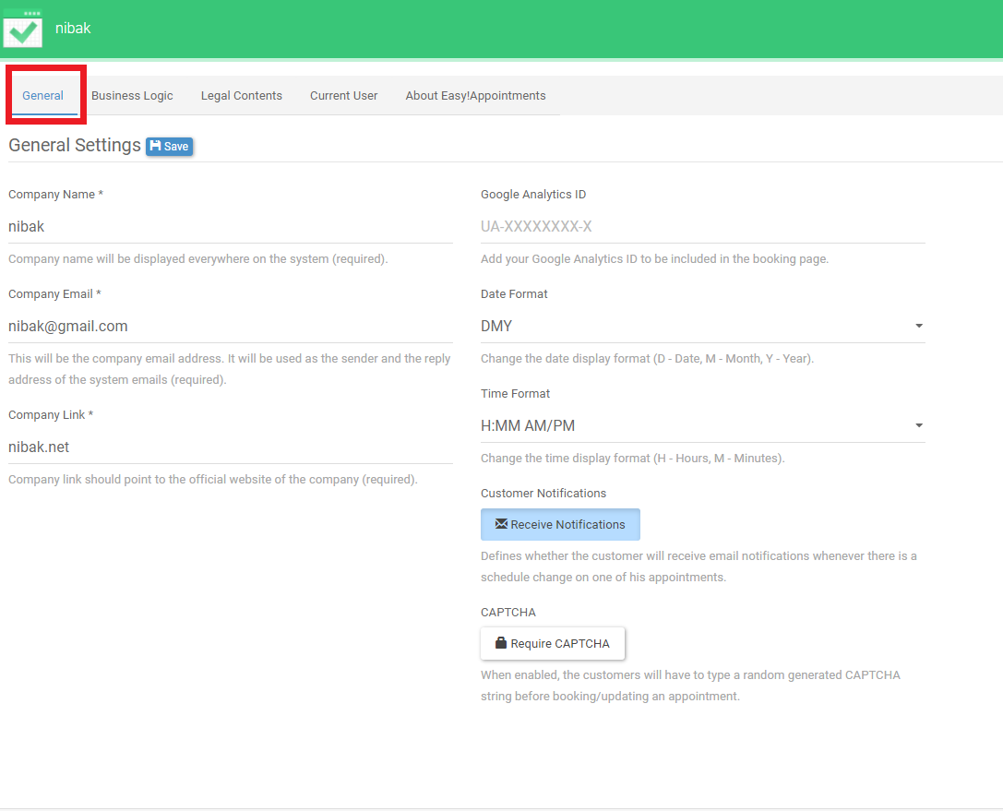

## Select General



## Select business logic

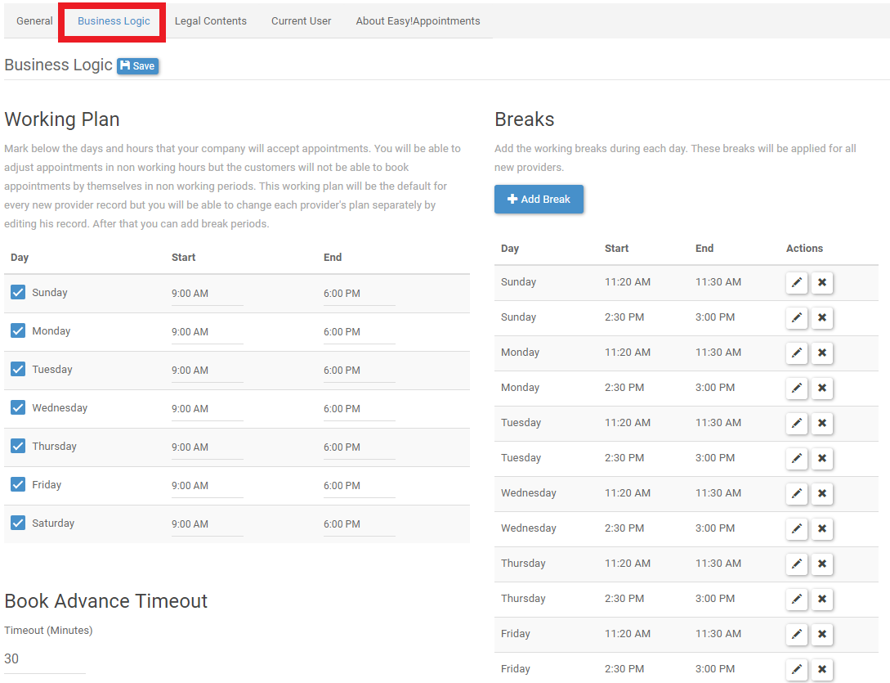

## Select Legal contents

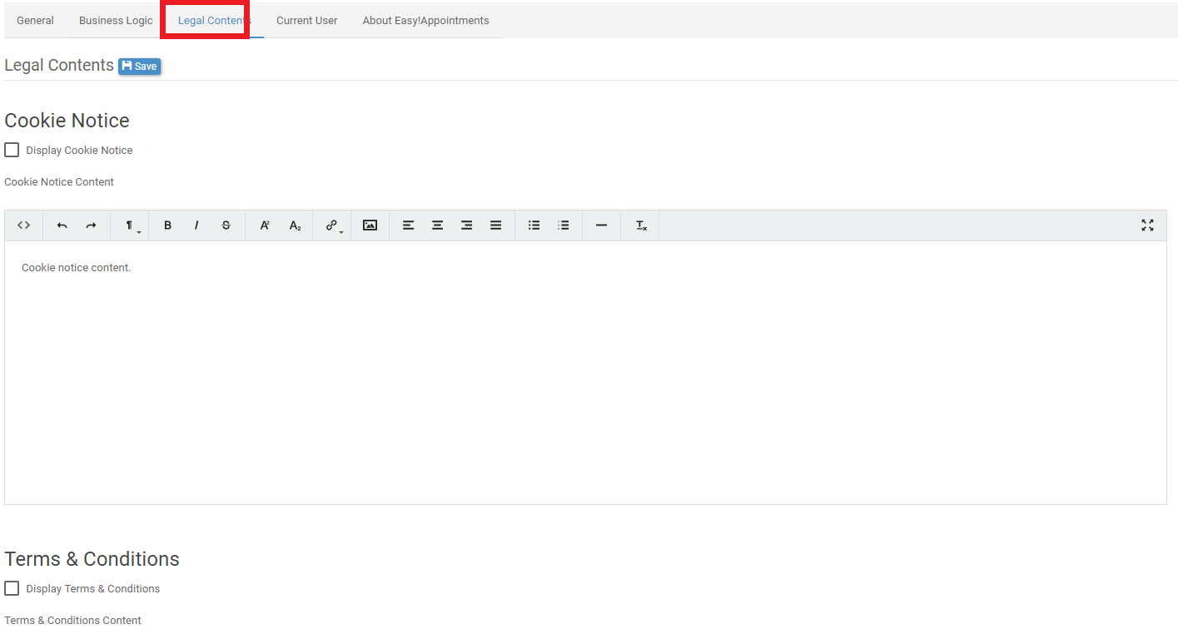

## Select current user

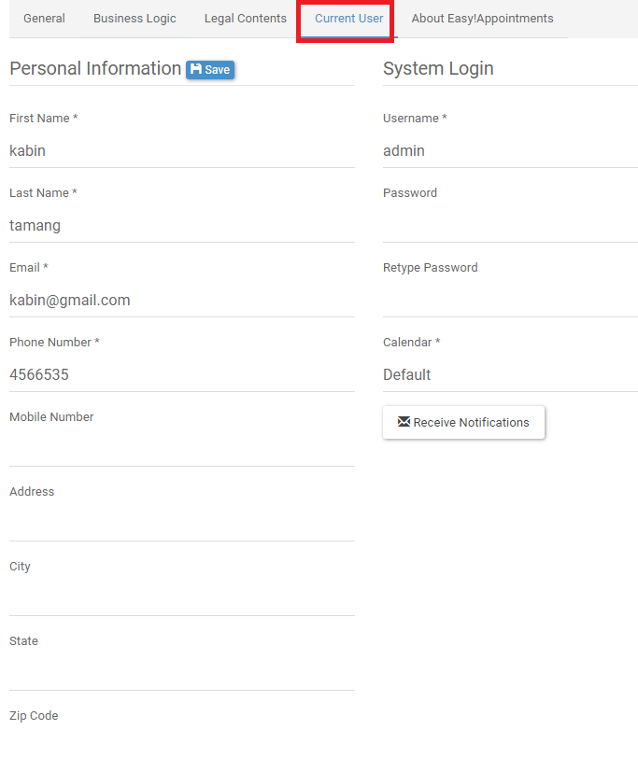

## About easy Appointments

You will see short description about easy appointment

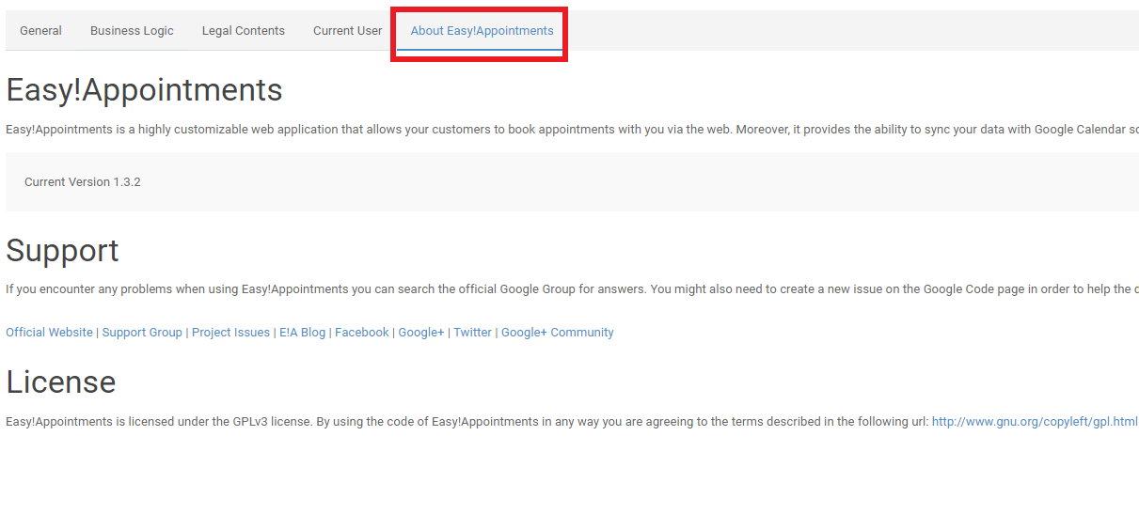

# Log out

There is logout on top-right screen where you can click on logout to logout from page.

